Cup Game
______________________________________________________________________________
April 12, 2010
Grade: 6th
Materials: Cups!
Big Idea: Relating and interacting to music as a group or ensemble.
Enduring Understanding:
- What is the importance of ensemble? What does ensemble establish? (feeling, emotion..)
- What does each individual contribute to the idea of ensemble?
- Importance of community in ensemble performance.
- How does the students feeling of accomplishment contribute to the idea of ensemble and community as a whole?
Process:
Anna:
Teach Cup Game Activity
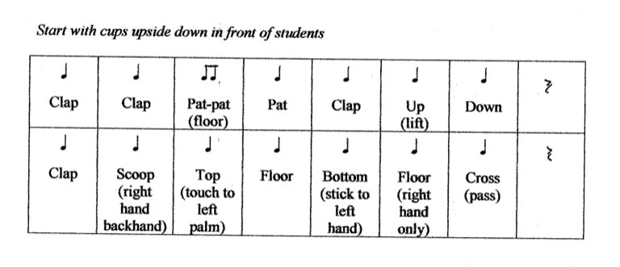
Demonstrate cup game activity for students. Teach part 1 and part 2 of the activity, with much repetition. Give students 5 minutes to practice the rhythm sequence on their own or with a partner. Bring students back together. Perform cup activity (5 times) as an ensemble.
Think – Pair – Share. Ask students to turn to their neighbor and name on thing they would like to improve in their performance next time we perform the sequence. Perform the sequence (5x).
Ask students to think about and share, what they would like to do better as an ensemble next time they perform the sequence. Make a list of “ensemble goals” things students would like to see improved or happening in their performance of the cup game. Perform sequence.

Brittany:
Divide the class into two groups and perform the cup-rhythm in cannon, then three or four groups. If the students are not getting it right away, ask what they think is difficult or challenging and how they can fix it. Discuss importance of ensemble awareness.
Mark:
Students will create their own cup-rhythm in groups of 4-5. Teacher will facilitate and help groups as needed. Each group should have a self selected leader who facilities within the mini-ensemble. Students will perform compositions for the class.

